University of economics – Varna
Bulgaria

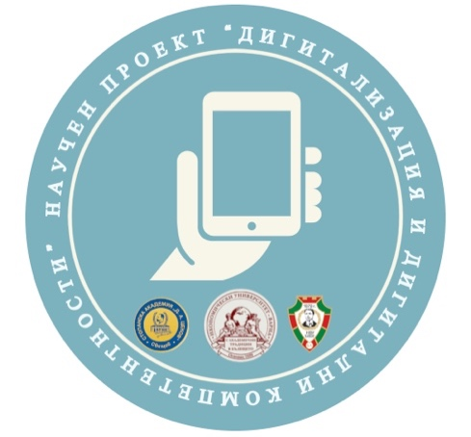


Call for Papers

The first international practical and scientific conference for students and PhD students

Digitalization in education – a step towards the successful professional realization

25 November 2021
Varna, Bulgaria
Overview
The conference is organized within the project "KP-06-H45/1"Digitalization and digital competencies in higher education and the labour market", funded by the National Research Fund.
The ambition of the organizers is to turn it into an annual event uniting the research activity of students and doctoral students not only from Bulgaria but also from abroad, with the support of their professors in the role of mentors and scientific consultants.
The conference aims to provoke the interest of students and PhD students in the current topic of digitalization in education, attracting them to research and sharing their attitudes, expectations and views on learning and working in the digital age.

Topics:
- Business and Management education in a digital environment – expectations and attitudes of students and PhD students to study and work in the digital age
- Contemporary digital technologies in Human Resource Management
- Digitalization and digital competencies in business and the public sector - challenges for modern employees, managers and entrepreneurs
- Ethical dilemmas, socially responsible and sustainable practices in the digital transformation of higher education and the labour market
- Digital transformation of the labour market and regulation of employer-employee relations
- Digital transformation in the legal system regulating business relations - challenges and trends

Submissions
Papers with a total volume of 8 – 10 pages are accepted, which are structured in an introduction, analysis and results, conclusions and references.
The papers can be developed individually or by student teams with no more than 4 students, led by a faculty member, whose name is indicated in the paper as a consultant (Research supervisor).
The layout for formatting the reports can be found on the conference website.
The conference will be held in a mixed format – in person and online.
Working languages ​​of the conference - Bulgarian and English.
There is no participation fee.

Publishing
All accepted and presented reports will be published in the proceedings of the first international practical and scientific conference for students and PhD students "Digitalization in education – a step towards successful professional realization" (2021) with ISSN.
All participants who have presented their reports will receive a certificate of participation.
A certificate of participation will be issued to the faculty members who have supervised the students.

Important dates:
Abstract submission deadline: November 10, 2021
Notification of abstract acceptance/rejection: November 15, 2021
Presentation submission deadline: November 22, 2021
Final paper submission: December 10, 2021

Contact:
Email address: digital_competencies@ue-varna.bg

